HTML Output:
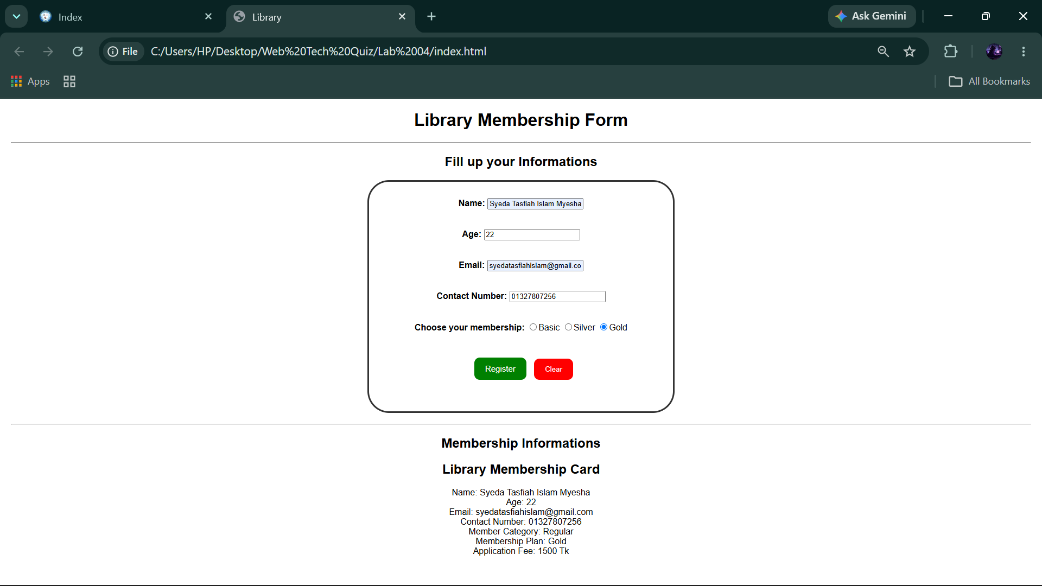
HTML Code:
<!DOCTYPE html>
<html>
<head>
<title>Library</title>
<link rel="stylesheet" href="style.css">
</head>
<body>

<h1>Library Membership Form</h1>

<hr>

<h2>Fill up your Informations</h2>

<form id="libraryForm">

<div>
<label for="name">Name:</label>
<input type="text" id="name" required>
</div><br><br>

<div>
<label for="age">Age:</label>
<input type="number" id="age" required>
</div><br><br>
<div>
<label for="email">Email:</label>
<input type="email" id="email" required>
</div><br><br>

<div>
<label for="contact">Contact Number:</label>
<input type="text" id="contact" required>
</div><br><br>

<div>
<label>Choose your membership:</label>
<input type="radio" name="membership" value="Basic" required>Basic
<input type="radio" name="membership" value="Silver">Silver
<input type="radio" name="membership" value="Gold">Gold
</div><br><br>

<div>
<input type="submit" value="Register">
<input type="reset" value="Clear">
</div><br>

</form>
<hr>
<h2>Membership Informations</h2>
<div id="output"></div>
<script src="script.js"></script>

</body>
</html>

CSS Code:
title, body, h1, h2{
text-align: center;
}
body {
font-family: Arial, sans-serif;
margin: 20px;
}
label {
font-weight: bold;
color: black;
}
form {
width: 500px;
max-width: 100%;
margin: 20px auto;
border: 3px solid #333;
padding: 30px;
background-color: white;
border-radius: 40px;
}
button, input[type="submit"] {
background-color: green;
color: white;
border: none;
padding: 12px 20px;
border-radius: 10px;
cursor: pointer;
font-size: 15px;
margin: 10px;
}
input[type="reset"] {
background-color: red;
color: white;
border: none;
padding: 12px 20px;
border-radius: 10px;
cursor: pointer;
}
button:hover, input[type="submit"]:hover {
background-color: darkgreen;
}

input[type="reset"]:hover {
background-color: darkred;
}

JavaScript Code:

function showMemberCard(name, age, email, contact, membership) {

let sections = ["Fiction", "Science", "History"];

console.log("Library Sections:");

for (let i = 0; i < sections.length; i++) {
console.log(sections[i]);
}

let category = age < 13 ? "Junior" : "Regular";

let fee = membership === "Basic" ? 500 :
membership === "Silver" ? 1000 : 1500;

document.getElementById("output").innerHTML =
"<h2>Library Membership Card</h2>" +
"Name: " + name + "<br>" +
"Age: " + age + "<br>" +
"Email: " + email + "<br>" +
"Contact Number: " + contact + "<br>" +
"Member Category: " + category + "<br>" +
"Membership Plan: " + membership + "<br>" +
"Application Fee: " + fee + " Tk";
}

document.getElementById("libraryForm").addEventListener("submit", function(event) {

event.preventDefault();

let name = document.getElementById("name").value;
let age = Number(document.getElementById("age").value);
let email = document.getElementById("email").value;
let contact = document.getElementById("contact").value;

let selectedMembership = document.querySelector('input[name="membership"]:checked');

if (!selectedMembership) {
alert("Please select a membership plan.");
return;
}

let membership = selectedMembership.value;

showMemberCard(name, age, email, contact, membership);

});

